**ERD for HUNGER POINT**

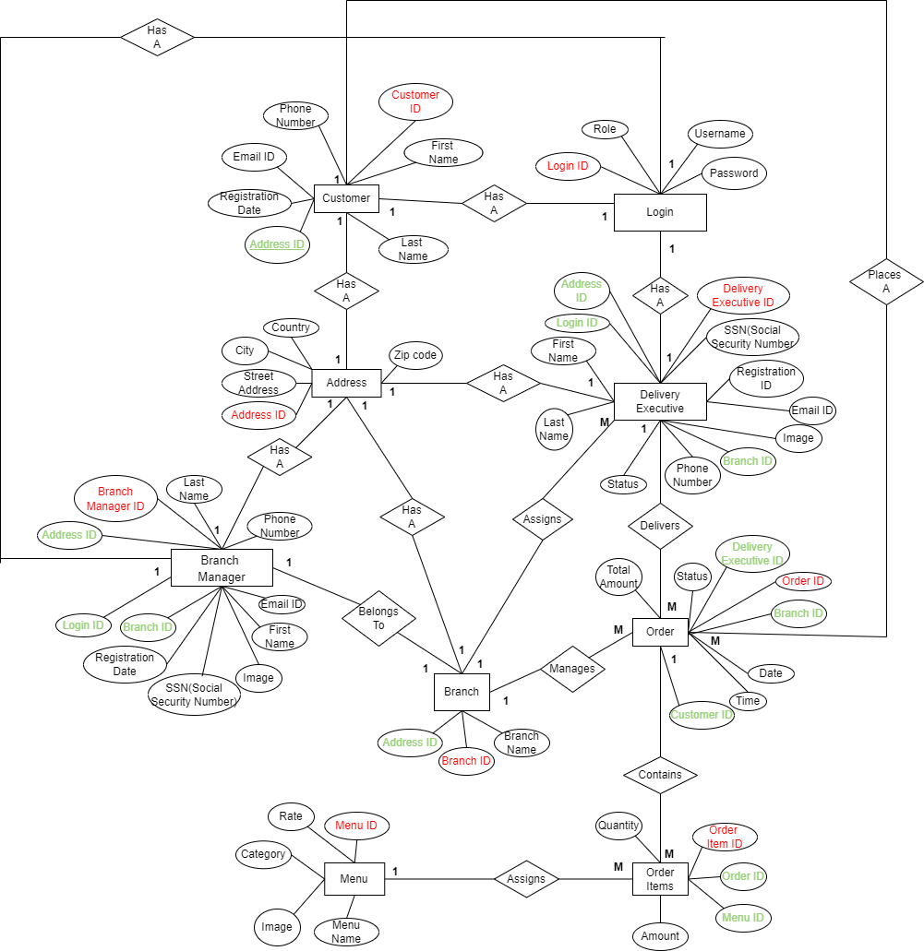



**Login:**

|  |  |  |  |
| --- | --- | --- | --- |
| **LoginID** | **Role** | **password** | **UserName (phone number)** |
| **PK,AG** | (customer,  admin/branch manager/delivery executive) |  |  |

**Customer:**

|  |  |  |  |  |  |  |  |  |
| --- | --- | --- | --- | --- | --- | --- | --- | --- |
| Customer_id | First Name | Last Name | Phone Number | Email ID | Registration_date | AddressID |  | LoginID |
| PK, AG |  |  | Not null  unique |  | Default value now() | FK (one to one) |  | FK (one to one) |

**Branch Manager:**

|  |  |  |  |  |  |  |  |  |  |  |
| --- | --- | --- | --- | --- | --- | --- | --- | --- | --- | --- |
| Branch_manager_id | **LoginID** | Branch_id | Image | SSN(social security number) | AddressID | First Name | Last Name | Phone Number | Email ID | Registration_date |
| PK | **FK(one to one),not null ,unique** | FK,Not null (one to one) |  | Unique, long | FK |  |  | Not null  unique |  | Default value now() |

**Branch : (hard coded in database, use insert stmt, no GUI)**

|  |  |  |
| --- | --- | --- |
| Branch_id | Branch_Name | AddressID |
| PK |  | FK(one to one) |

**Delivery Executive: (hard coded in database, use insert stmt directly ,no GUI)**

|  |  |  |  |  |  |  |  |  |  |  |  |
| --- | --- | --- | --- | --- | --- | --- | --- | --- | --- | --- | --- |
| Delivery Executive ID | Login ID | SSN(social security number) | Image | Branch_id | AddressID | First Name | Last Name | Phone Number | Email ID | Registration_date | Status(occupied/available) |
| PK | FK |  |  | FK | FK |  |  | Not null  unique |  | Default value now() |  |

**Address:**

|  |  |  |  |  |
| --- | --- | --- | --- | --- |
| Address_ID | Street address | City | Country | Zip code |
| PK |  |  |  |  |

**Order:**

|  |  |  |  |  |  |  |  |  |
| --- | --- | --- | --- | --- | --- | --- | --- | --- |
| Order ID | Date | Time | Status  (placed, cancelled,  in process,  Dispatched, delivered) | Total Amount(sum of amount(order item)) | Customer ID | (payment by cash) | Delivery Executive ID | Branch ID |
| PK, AG |  |  |  | 200+300=500 | FK |  | FK | FK |

**Order Item:**

|  |  |  |  |  |
| --- | --- | --- | --- | --- |
| Order ID | Menu ID | Amount | Quantity | Order Item ID |
| FK | FK, one to many | 100*2=200 | 2 | PK |

**Menu:**

|  |  |  |  |  |
| --- | --- | --- | --- | --- |
| Menu ID | Menu Name | Category | Image | Rate |
| PK, AG |  |  |  | 100 |

Card(we are not maintaining card details after user logout /session expires without placing order, so card table not needed and card details are kept in session)

|  |  |  |  |
| --- | --- | --- | --- |
|  |  |  |  |
|  |  |  |  |

**SYSTEM DESIGN**

2. Notify about order

Branch Manager Module

Customer Module

1. Place order

4.

Notify about parcel prepared

3.

Notify about parcel prepared

7.

Notify about parcel delivery

5. Notify about parcel picked up

Delivery Executive

6. Notify about parcel delivered